Task on S3
- Create an S3 bucket and upload some objects to S3.
Steps:
Login to AWS Console
- Search: S3
- Click Create bucket
Configure bucket
- Bucket name: s3-test-buc-test(globally-unique)
- Region: eu-north-1 , and Keep defaults
- Click Create bucket
- Open created bucket and Click Upload after Add files
- Select files (example: image/jpeg)
- Click Upload

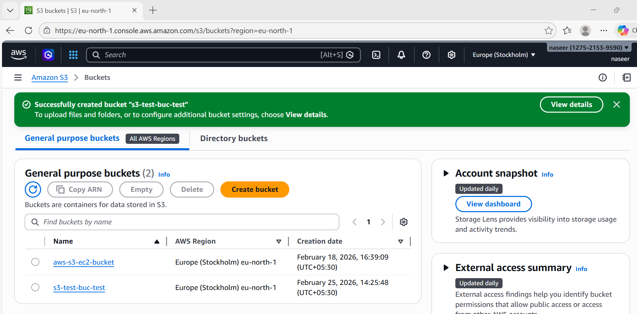
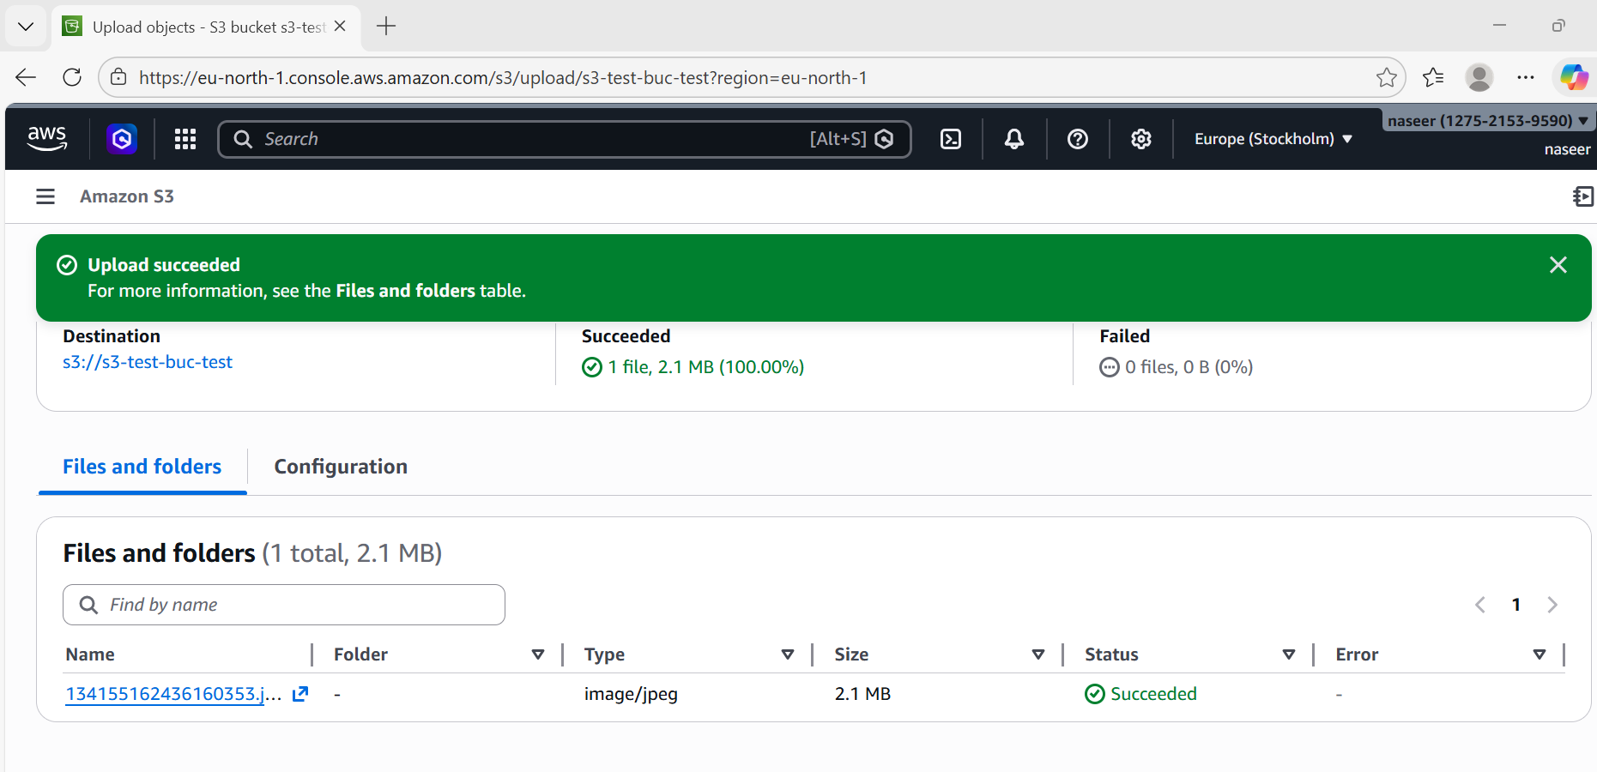
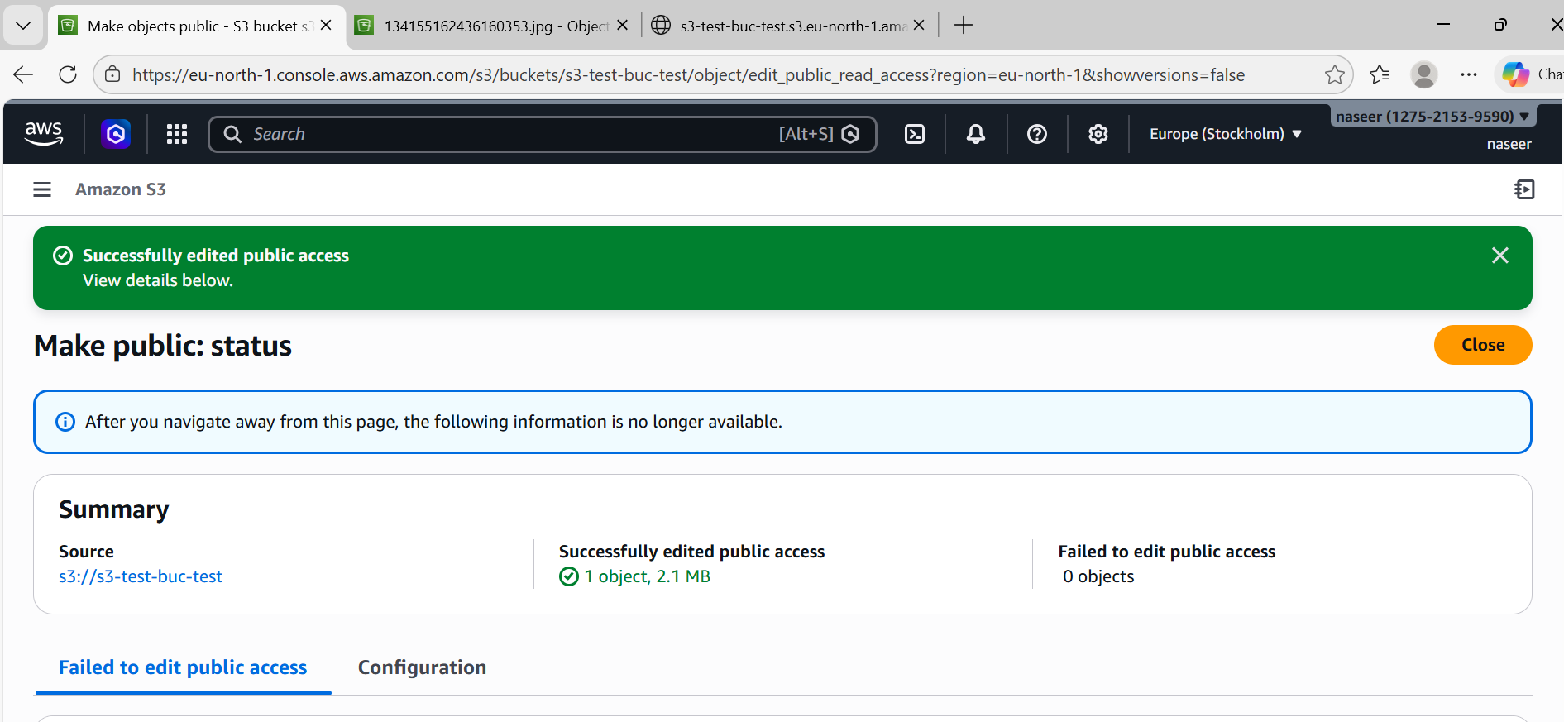
- Deploy a static website in the S3 bucket.
Steps:
- Go to S3 → Your bucket and Click on Properties
- Scroll → Static website hosting, Click Edit
- Enable → Static website hosting
Enter: Index document: index.html
Error document: error.html click on Save
Access website
Go to:
Properties → Static website hosting
You will get URL, select URL and on paste on browser

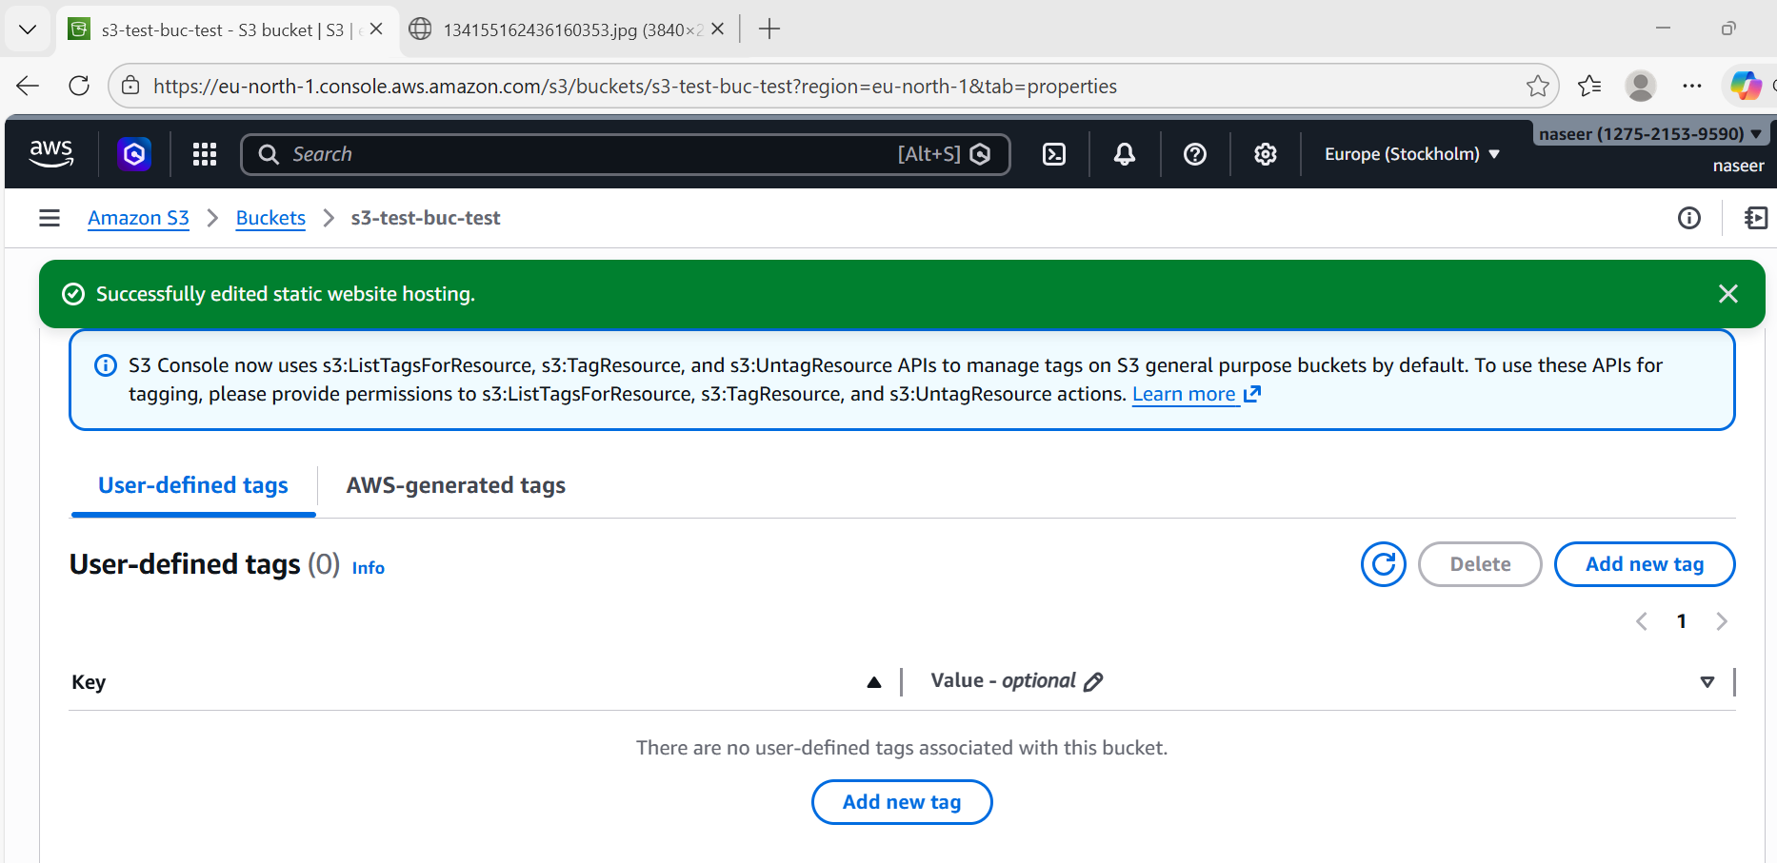
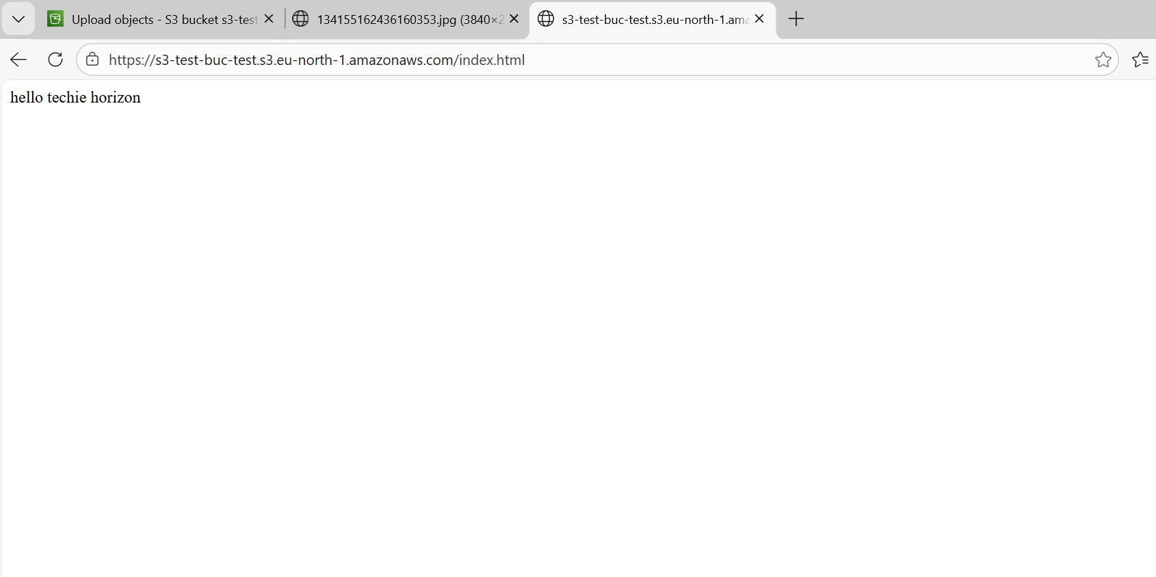

- Enable cross-region replication on S3 buckets.
Steps:
Create destination bucket
Enable versioning on both buckets
Source bucket: Properties → Versioning → Enable
Destination bucket: Properties → Versioning → Enable
Create replication rule
Source bucket → Management → Replication → Create rule
Enter: Rule name: replication-rule
Destination bucket: vpc-flowlogs-bucket-12345
Create IAM role automatically
Save
Now upload file → automatically replicated to other region
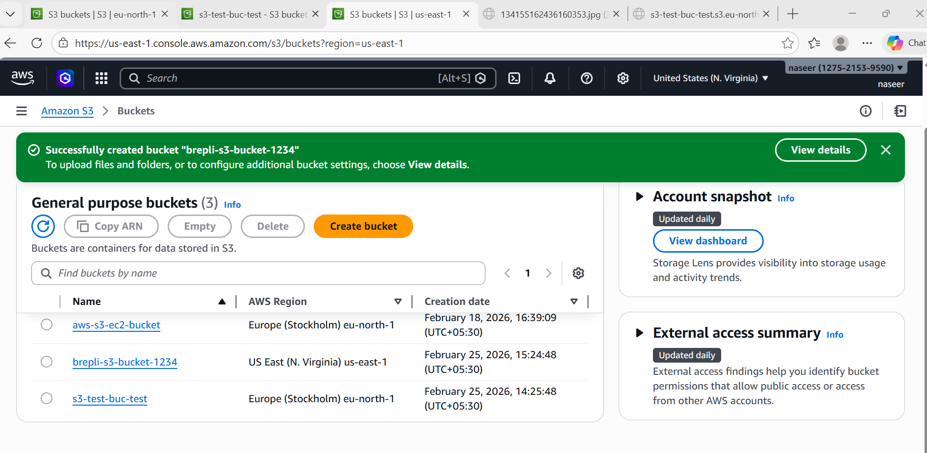
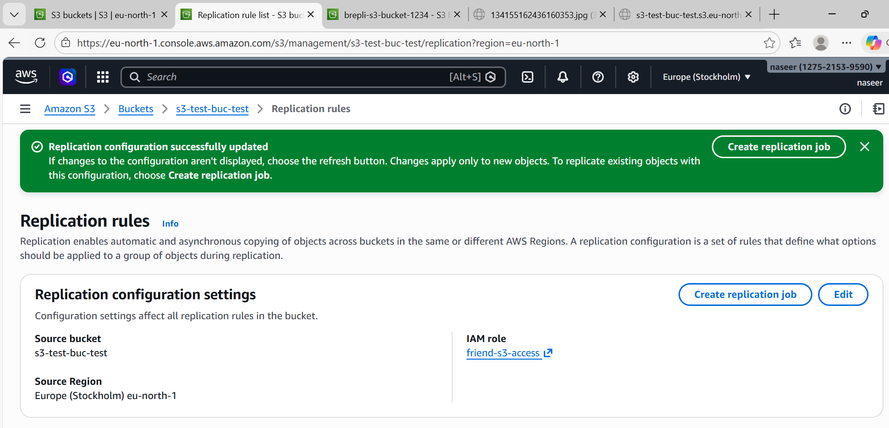
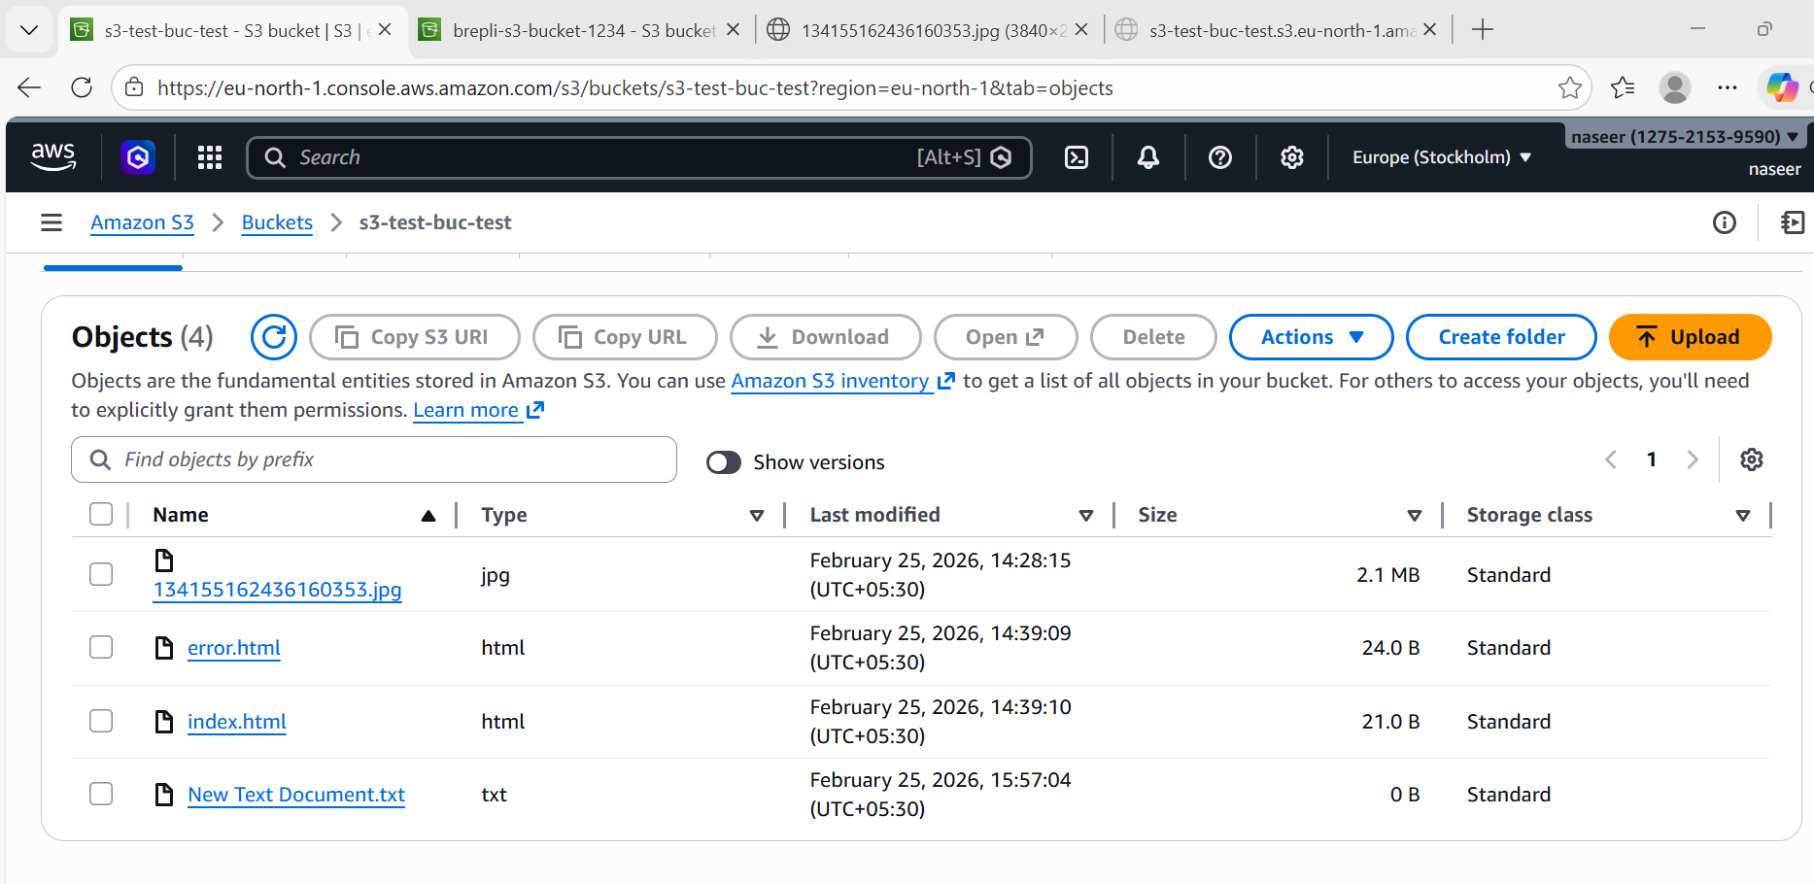
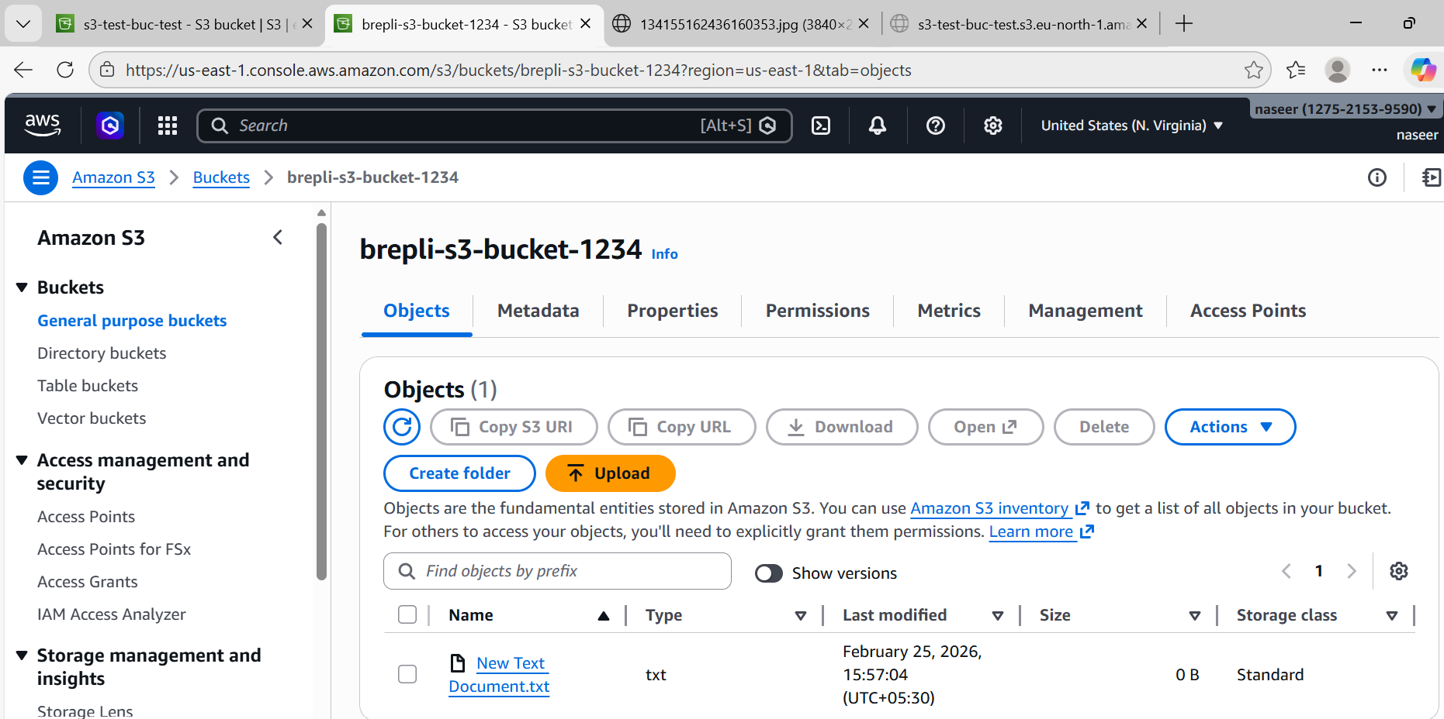
- Configure a bucket policy so only the Admin user can see the objects of the S3 bucket.
Steps:
Create S3 Bucket
1. Login to AWS Console
2. Open S3 service
3. Click Create bucket
4. Enter bucket name and Select region
6. Disable Block Public Access (if needed)
7. Click Create bucket
Create Admin User
1. Open IAM service
2. Click Users → Create user
3. Enter name: Admin
4. Enable console access
5. Attach policy: AmazonS3FullAccess
6. Create user and save credentials
Create Test User
1. Go to IAM → Users → Create user
2. Enter name: Test User
3. Enable console access
4. Attach policy: AmazonS3FullAccess
5. Create user
Apply Bucket Policy
Go to S3 → Bucket → Permissions → Bucket Policy
Test Access
Login as Admin → Access allowed
Login as Test User → Access denied

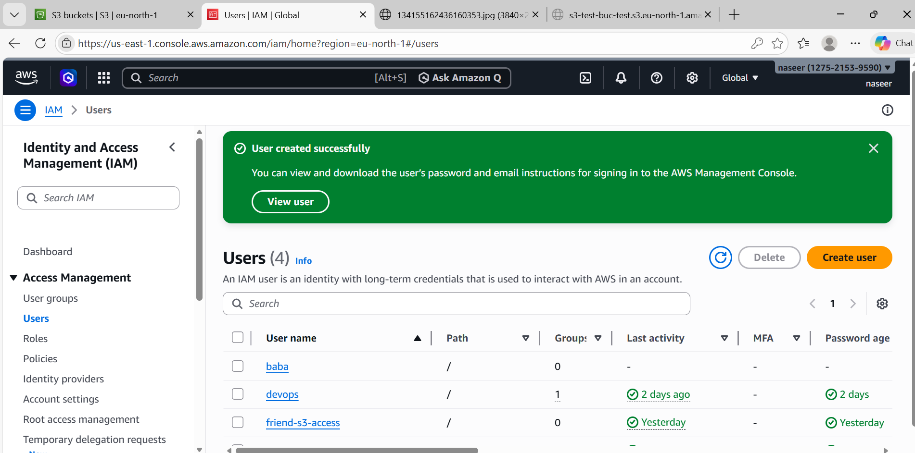
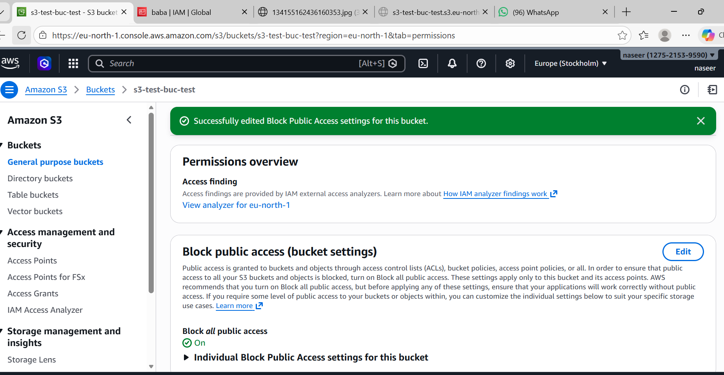
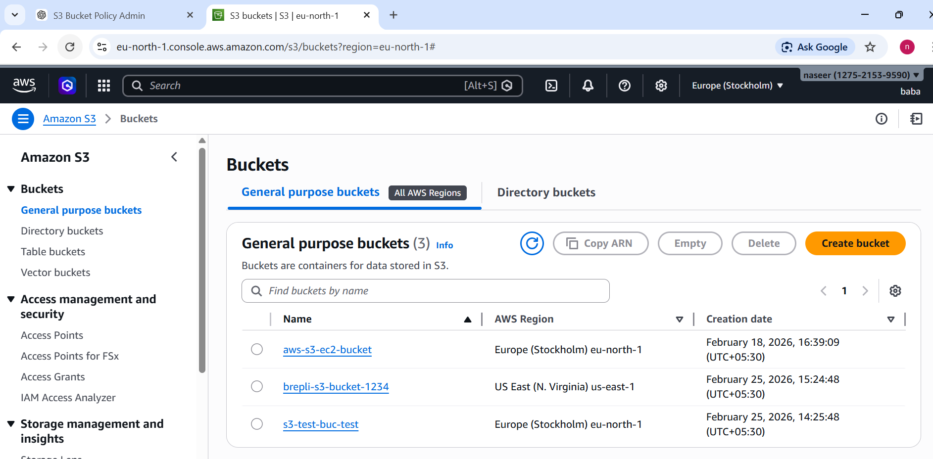
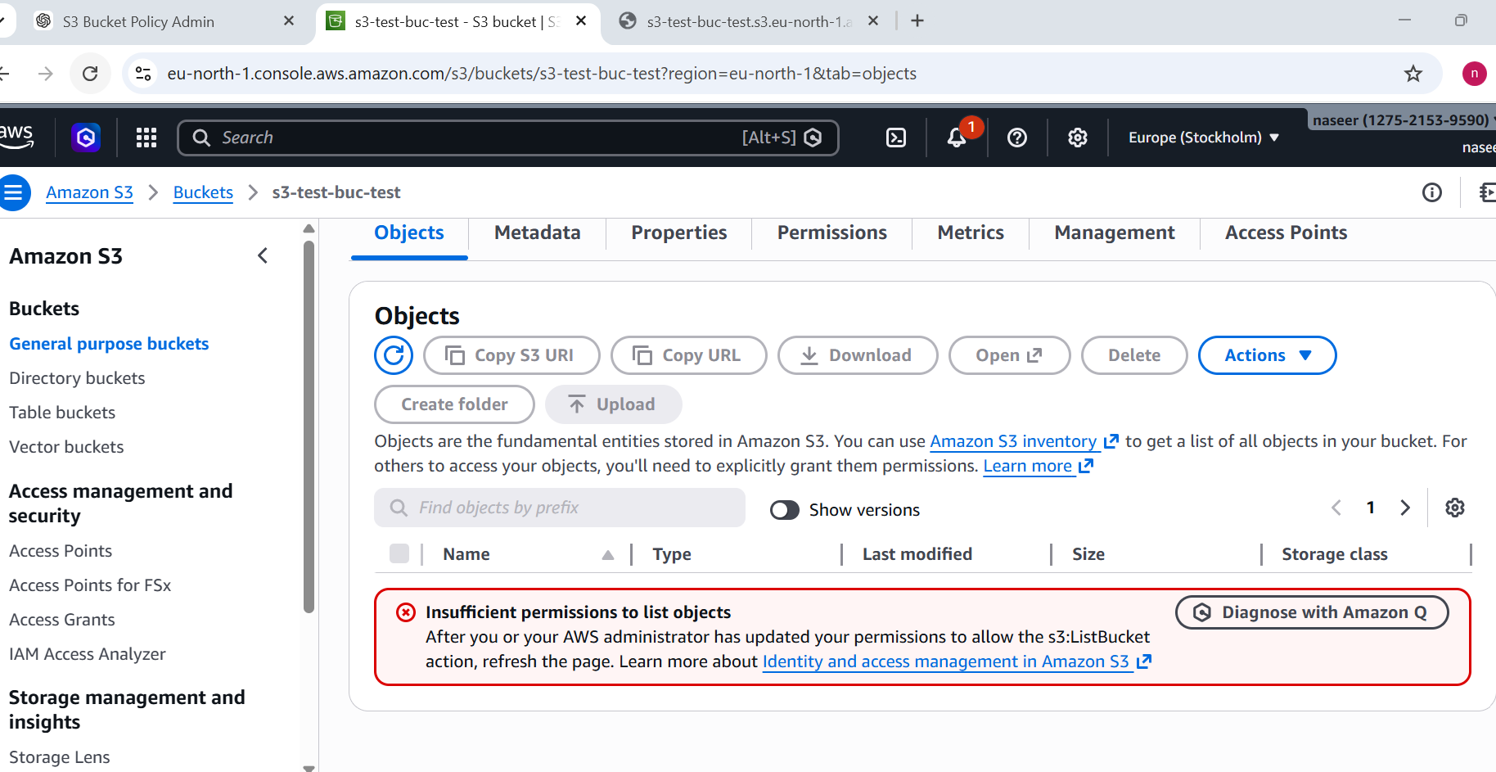

- Set up lifecycle policies to automatically transition or delete objects based on specific criteria.
Steps:
Open S3 bucket
Go to AWS Console → S3 → Buckets->Click your bucket
Go to Management tab and Click Management
You will see Lifecycle rules Click Create lifecycle rule
Enter rule nameNextChoose scope
Select Apply to all objects in the bucket
Configure Transition (move to cheaper storage)
Add transition Transition to Glacier Flexible Retrieval
Days after object creation: 30
This means: After 30 days → move to Glacier
Days after object move to Glacier: 60
This means: After 60 days → permanently delete
Configure Expiration (delete objects)
Review and create
Review settings
Click:
Create rule
Lifecycle policy created

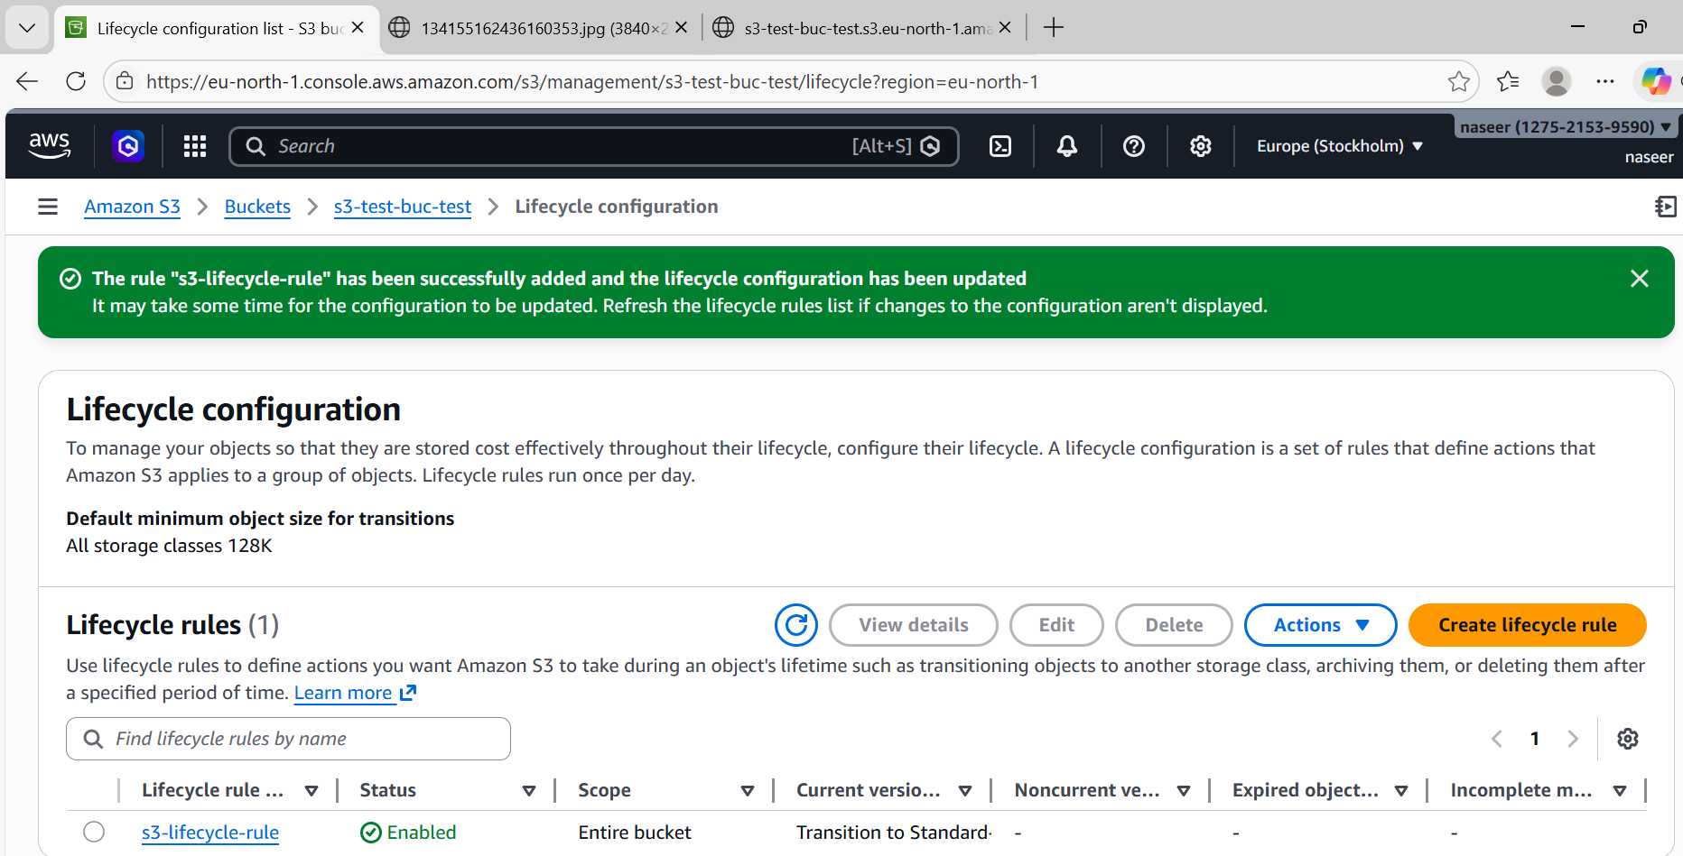
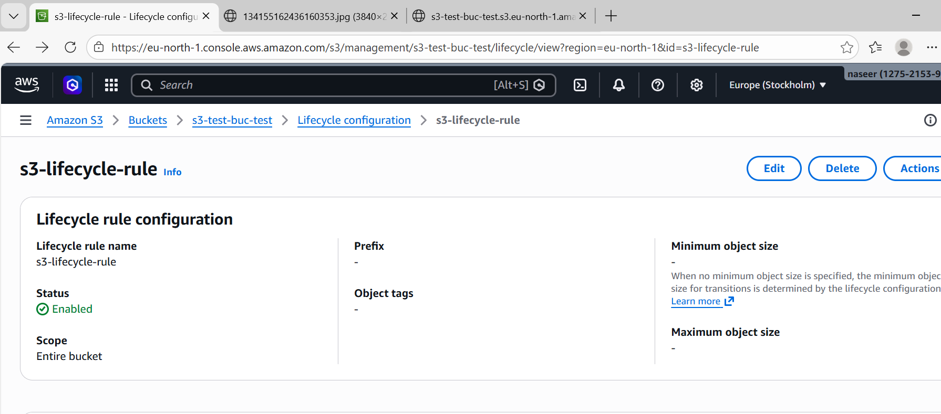
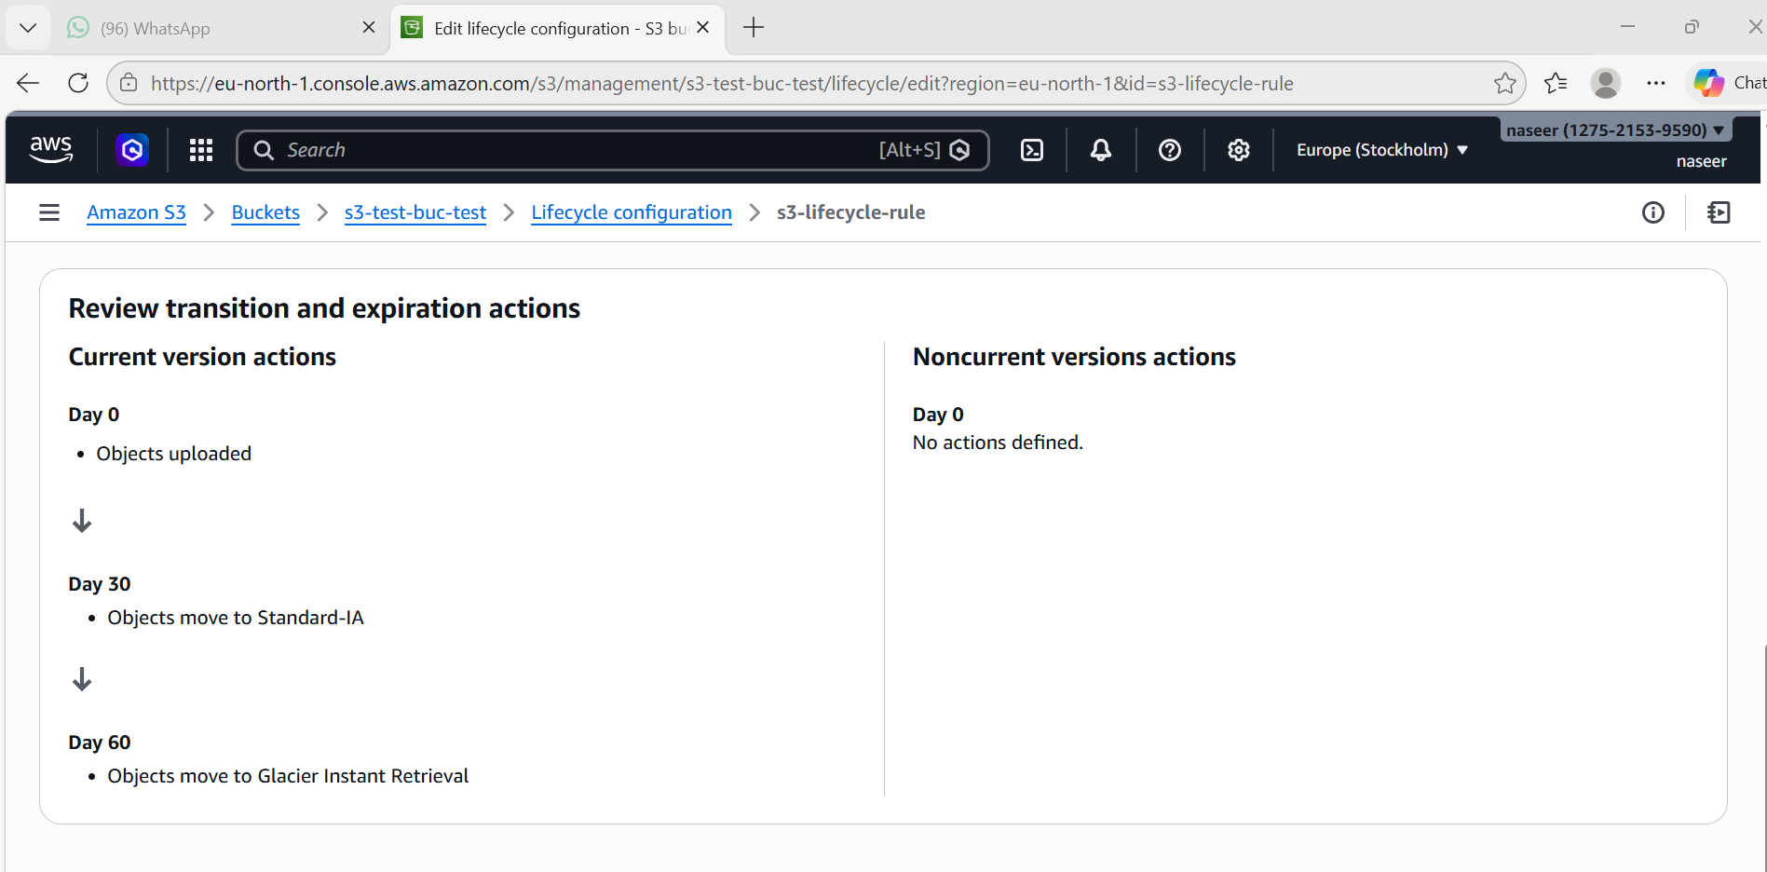
- Push some objects to S3 using the AWS CLI.
Steps:
Install AWS CLI (if not installed)
Check:
aws --version
If not installed (Ubuntu/Linux):
sudo apt update
sudo apt install awscli -y
Configure AWS CLI
Run:
aws configure
Enter:
AWS Access Key ID: (paste your access key)
AWS Secret Access Key: (paste secret key)
Default region name: eu-north-1
Default output format: json
You will see:
Configuration saved
Upload file to S3
Syntax:
aws s3 cp filename s3://bucket-name/
aws s3 cp index.html s3://aws-s3-ec2-bucket/
Verify upload
Run:
aws s3 ls s3://aws-s3-ec2-bucket
Output:
index.html
Upload successful

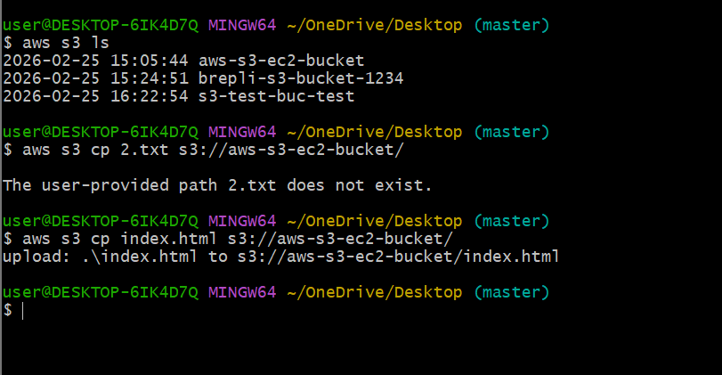
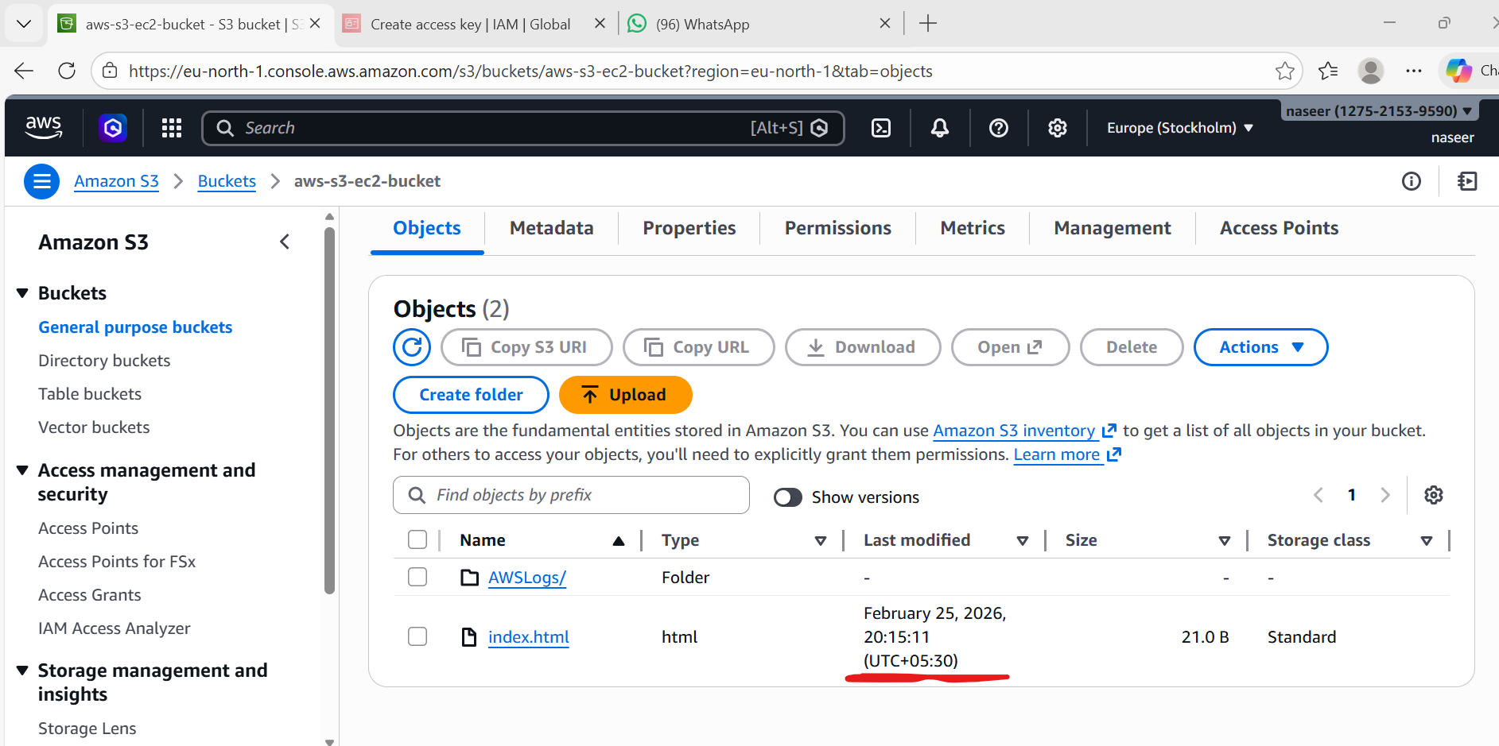

- Write a Bash script to create an S3 bucket.
Steps :
Create script file
nano create-bucket.sh
Paste this script
#!/bin/bash
BUCKET_NAME=my-bash-bucket-4321
REGION=us-east-1
aws s3api create-bucket \
--bucket $BUCKET_NAME \
--region $REGION
echo "Bucket created successfully: $BUCKET_NAME"
Save:
CTRL + C
CTRL + X
Enter
Give execute permission
chmod +x create-bucket.sh
Run script
./create-bucket.sh
Output:
Bucket created successfully: my-bash-bucket-4321
Verify:
aws s3 ls

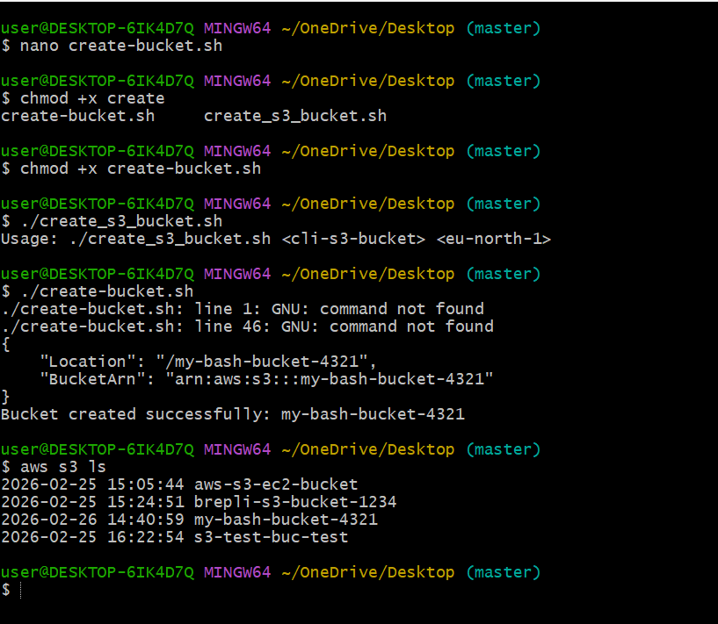
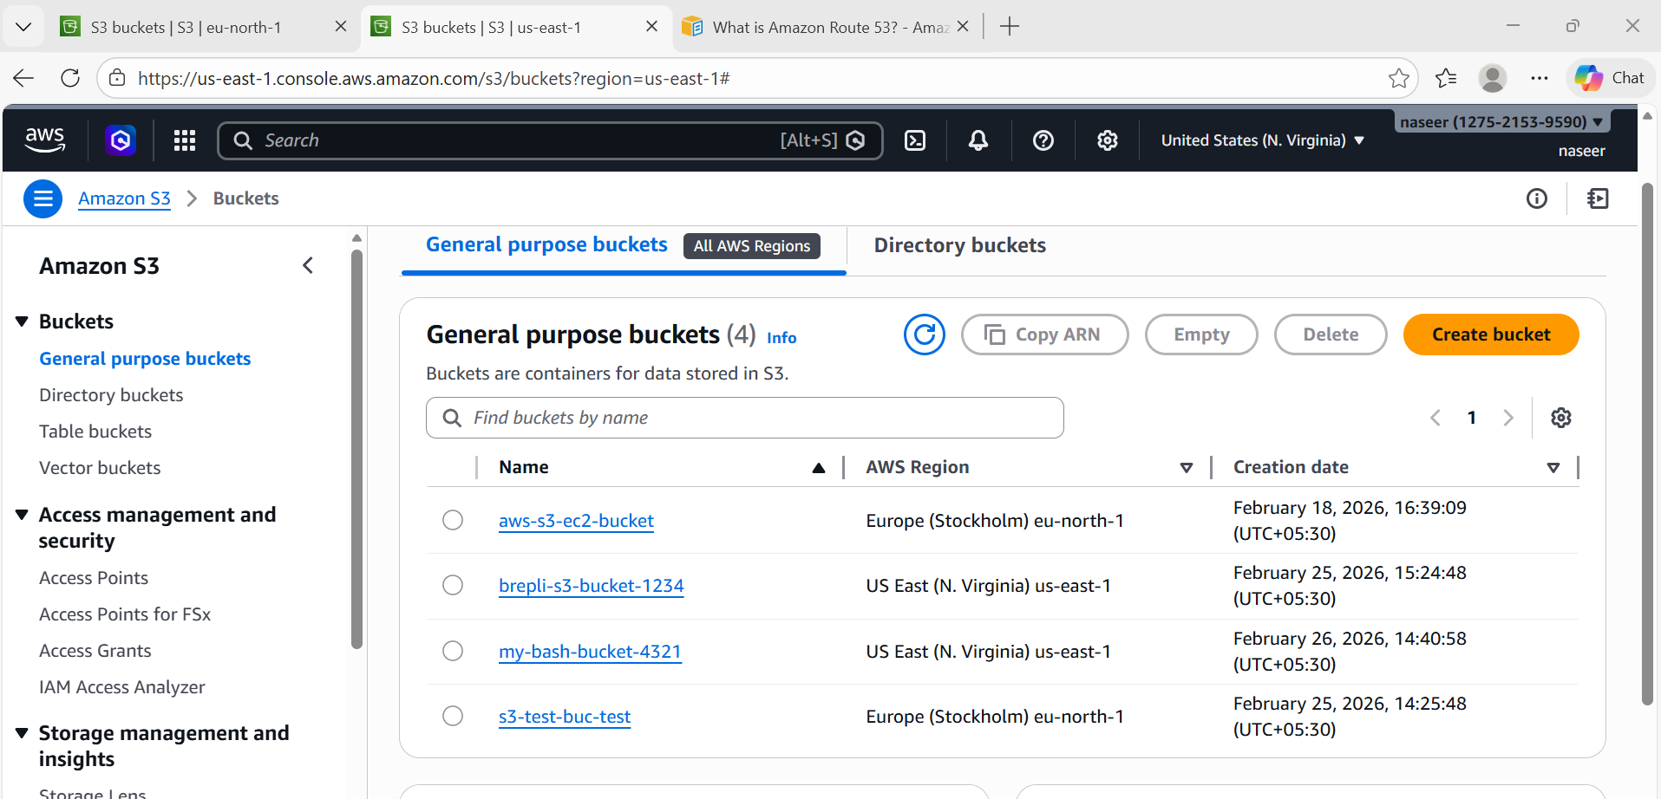

- Upload a 1 GB file to S3 using the CLI.
Steps:
Create 1GB test file
Linux:
dd if=/dev/zero of=1GBfile bs=1M count=1024
This creates: 1GBfile
Upload 1GB file
aws s3 cp 1GBfile s3://s3-test-buc-test/
AWS will automatically use:
Multipart upload
Verify upload
aws s3 ls s3://s3-test-buc-test
Output:
1GBfile
Upload successful

